Python and PyCharm install and Setup

**Important Information:**

If your windows system is 32bit, we suggest that upgrade to 64bit.

1. Install python

1.1 Download python from <https://www.python.org/downloads/release/python-385/>

Please select [Windows x86-64 executable installer](https://www.python.org/ftp/python/3.8.5/python-3.8.5-amd64.exe)

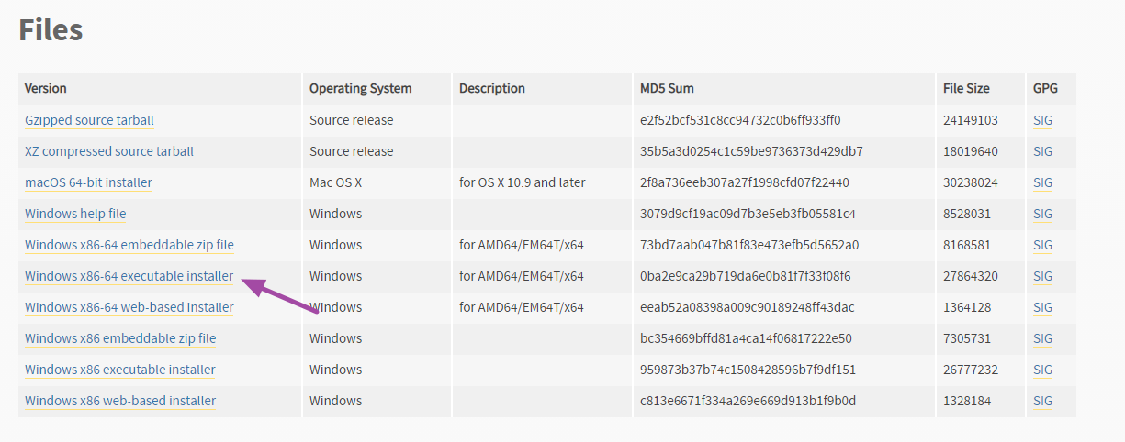

* 1. Install python

Click install Now

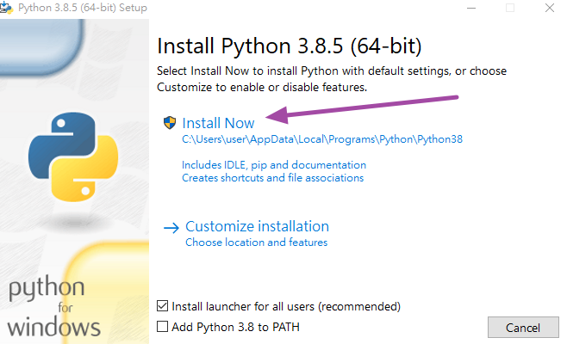

* 1. Click Close to finish installation

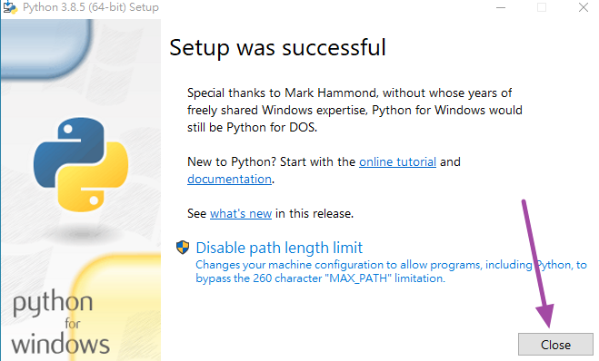

1. Install PyCharm
   1. Download pycharm (<https://www.jetbrains.com/pycharm/download/#section=windows>)

Please download community version, it is free.

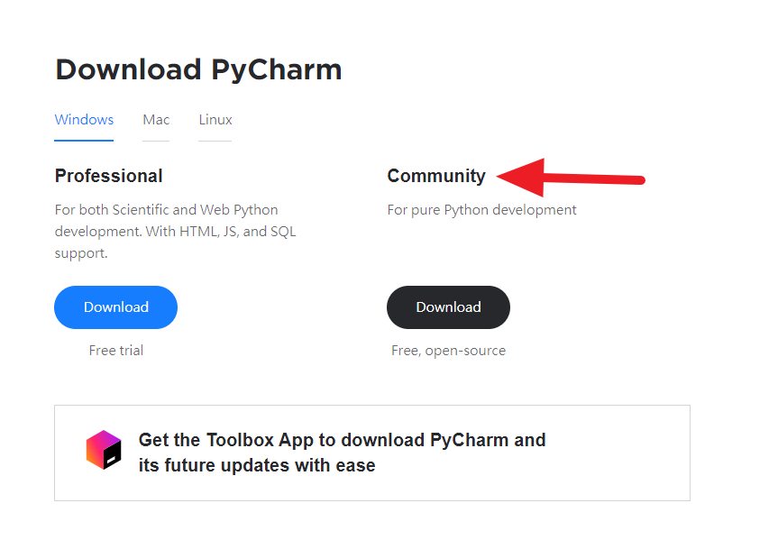

2.2 Click Next

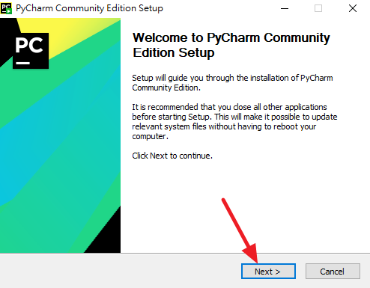

2.3 Click Next

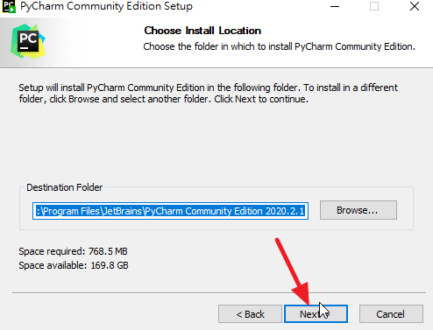

2.4 Select two items and Next

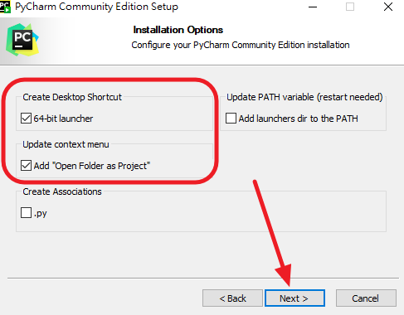

* 1. Click Finish to complete installation

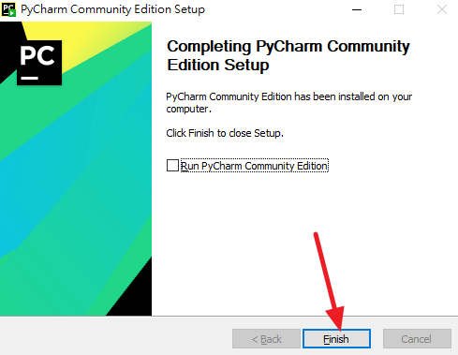

1. PyCharm Setup
   1. Run PyCharm program

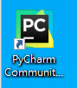

* 1. Select New project

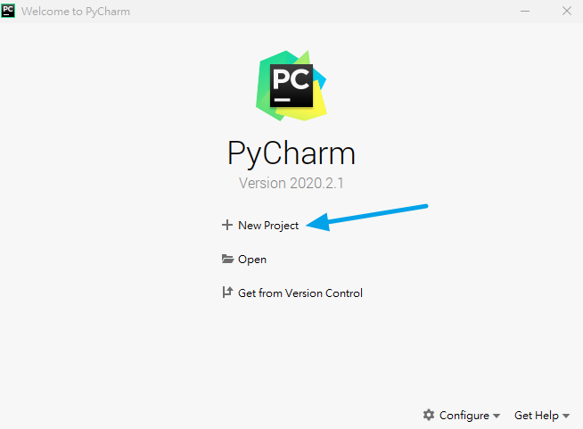

* 1. Create New folder

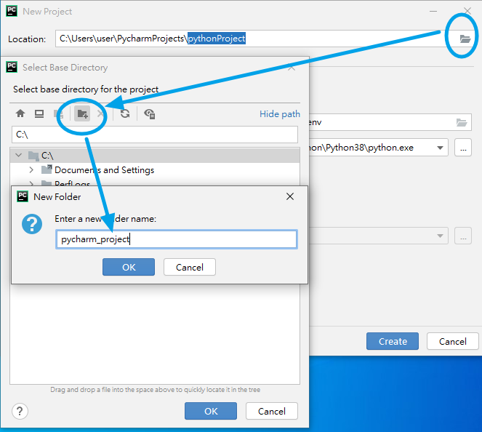

3.4 Create subfolder, the folder name name is ASLung.

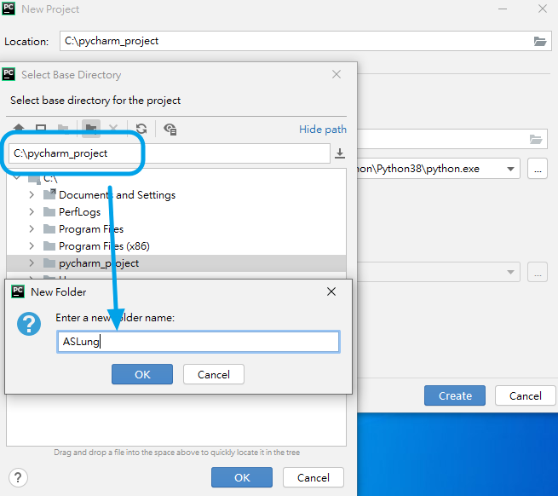

* 1. Click Create

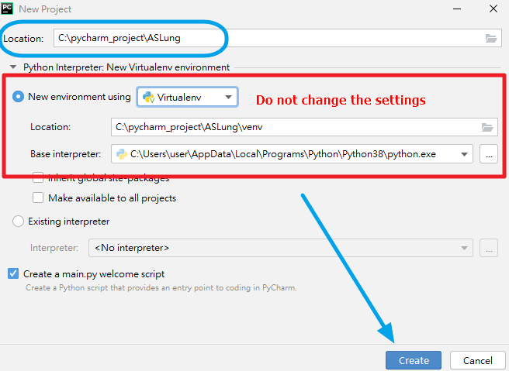

3.6 If you see the window, PyCharm is work.

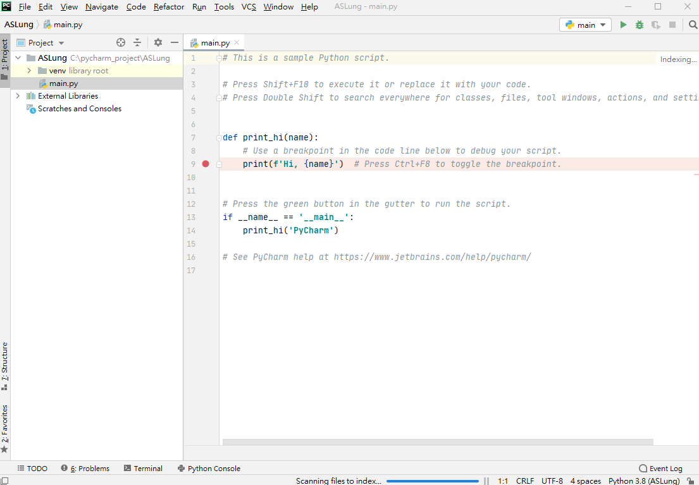

1. Install python packages

4.1 Click Terminal function, you will see a terminal window

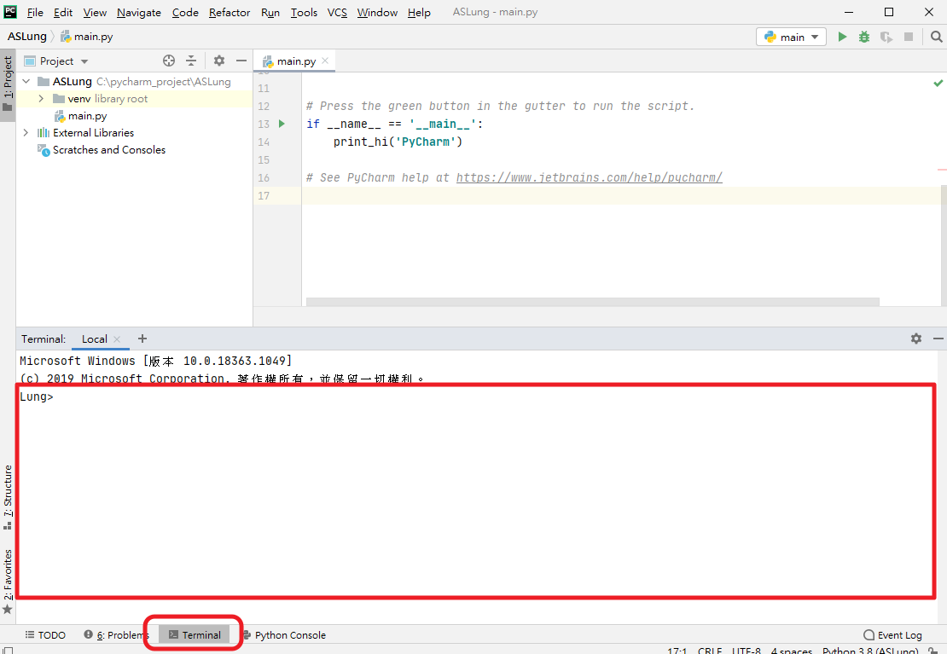

4.2 Type “pip install pandas” in the terminal window then press “Enter” to install pandas package.

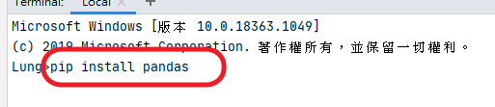

4.3 PyCharm will download and install package.

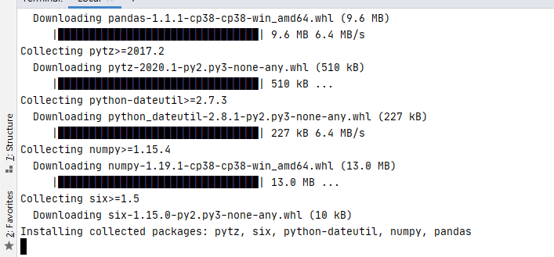

4.4 If you see “successfully installed………”, package has been installed.



* 1. Please install other packages under the list:

1. pwlf
2. sklearn
3. multiprocess
4. xlrd
5. statsmodels